CHAPTER IV: SYSTEM ANALYSIS AND DESIGN

INTRODUCTION

To build an innovative system that automates identifies student faces, and which done wrong thing and identifying which class goes. Our system uses University CCTV camera to captured images.

So, this chapter focuses on the analysis and design of a developing Image-based Student Identification and Classification using Face Recognition, which is an important stage when developing systems such as Web Application.

Existing Approaches

Traditionally, In the university system, not all gives ability to differ from accused student's and lawful student's. The student simply done what they want without worrying to identify so quickly in the university building.
The traditional way has a number of problems which include the following:
- Traditional way are difficult to accurately differentiate between an ac accused student and an lawful student before taking decision.
- Traditional way require a lot of time to recognize the face and which class he/she attendance.

The Purposed System

This system is designed to monitor students’ face recognition and solve the drawbacks of old way. It has two functions including face recognition and suspect face. First, the system is recognizes face fully without suspecting others when the camera captured Image for fully faces and the camera took photo distance about 10 meter and about quality of 8MP or greater that Image can recognize 99.99%. The suspect faces when camera took part of the face like one side such as one eye, one ear, part of noise one jaw and part of chin when have this side we will list number of students suspected to done by this act.

System Requirements

A requirement is a written document of a characteristic that a new system must have. In this section, researchers discuss requirements for the Image-based Student Identification and Classification using Face Recognition and classify the requirement into two parts Functional Requirements and Non-Functional Requirements.

Functional Requirements

A functional requirement is a requirement that describes an activity of your system. The following are the requirements that the proposed system should functionally achieve.
Admin registration: the system is capable of registering an authenticated user to allow access to the system.
Training System: The system will allow you to train students data including his Image to recognize his face.
To Identification: is to pass image captured by the camera and return student ID,Name,Class and so.

Non-Functional Requirements

A non-functional requirement is one that specifies how to determine whether a functional requirement has been met. The following are the non-functional requirements that the proposed system must meet:
- Security: The system should be secure in order to ensure the privacy of its users.
- Availability: The system is accessible via the internet and can be accessed at any
time and from any location.
- Privacy: The system can only be used by administrators and authorized users.
- User Friendly: The system is simple and interesting.

Feasibility of Study

Operational feasibility

The proposed system is divided into three main parts, the first part consists of training data. The second segment consists of a the second is testing therefore the third segment is a website that manages users to allow access .

Technical feasibility

The technical resources needed to develop a QR-Code Based Exam Hall Authentication and Attendance System with Temperature Sensing Using the Internet of Things (IoT) include Raspberry PI 4, Buzzer, and body temperature sensor. The Raspberry Pi uses the Raspbian OS and is programmed using open-source GNU Octave and Python. also, researchers needed to install Android Studio, Visual Studio Code, and computers running Linux operating systems OS also install LAMPP Server for MySQL database, Firefox Browser or Brave Browser for security and Chrome Browser (Optional), all these technical resources needed are detailed explanation in chapter 3.

Economic Feasibility

The proposed system benefits include ongoing support and maintenance costs, as well as
acquisition costs. The determined total cost of the study, including all required hardware
costs, is approximately $ 220.99.

System Design

System design is the process of designing the elements of a system such as the architecture, modules, and components, the various interfaces of these components, and therefore the data that goes through that system. The objective of the system is to process of creating or alter new systems, along with the processes, practices, models, and methodologies used to develop them. The system design describes activities that involve specifying how the proposed system operates and works. We use UML to create system design and its various components. UML diagrams are used and analyzed using diagrams and activity diagrams.

Exam Hall Authentication System

Investigator
USERS
STUDENTS
Investigation RESULT
ADMINISTRATOR

Investigator

Figure 14.1 Use Case Diagram for EXAMAUTHSYS

- Create User Account
Create Users

Administrator
Figure 24.2 Create User Account

Brief description

This function allows the system administrator to create a new user.

Basic flow

- The admin accesses the system and chooses the new account function to create a user account.
- The system displays a registration form, including a Username, Password, User type and etc.
- The Administrator fills out the registration form and submits it.

- Register Investigator and Student
Register Investigator
Register Student

Administrator
Figure 34.3 Register Invesitagor and Student

Brief description

This function allows the system administrator to register new Investigator and students.

Basic flow

- The admin accesses the system and chooses the registration form.
- The system displays a registration form of the investigator, including the investigator Name and telephone.
- The system displays a registration form of the student, including Student ID, Name, and class.
- The Administrator fills out the registration form of the investigator and submits it.
- The Administrator fills out the registration form the student and submits it.

Brief description

This function allows the system administrator to register classes and halls.

Basic flow

- The admin accesses the system and chooses the registration form.
- The system displays a registration form of the Im, including Class Name.
- The system displays a registration form of the Hall, including the Hall Name and campus type.
- The Administrator fills out the registration form for the Class and submits it.
- The Administrator fills out the registration form for the Hall and submits it.

Start
verify
No
train
investagate
Duplicate image
Same person
There is no face
Saved
yes
There is no face
suspected
Regocagnized
There is a face
Not Regocagnized

Figure 44.5 System Design

Database Design

Database design is the organization of data according to a database model to determine what data must be stored and how the data elements interrelate. With this information, they can begin to fit the data into the database model. The designing database is a properly is fundamental to establishing a database that meets user needs. The main purpose of designing a database is to produce physical and logical models of designs for the proposed database system.

- Database diagram
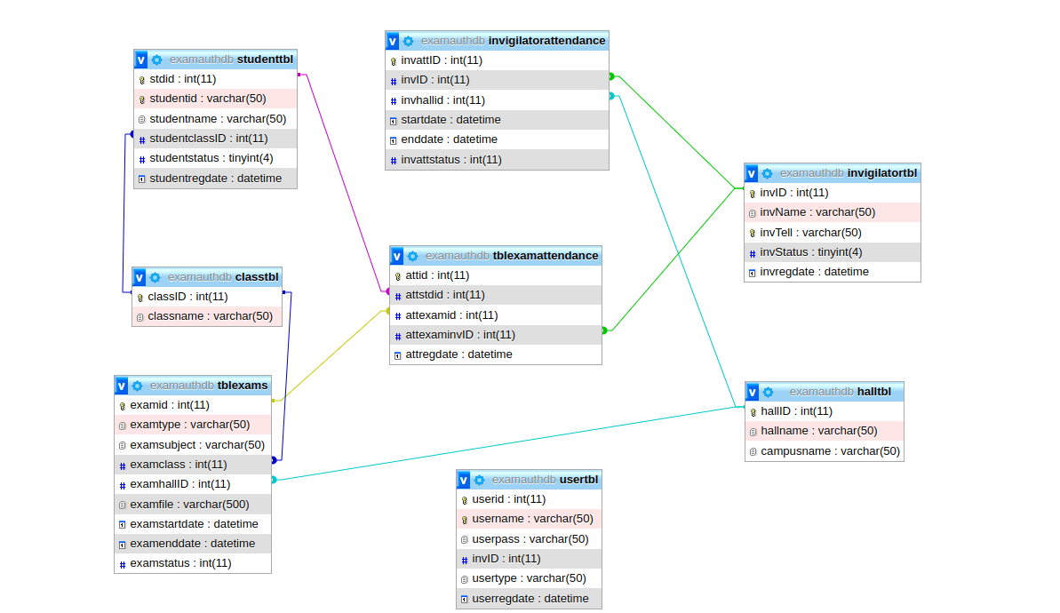

Figure 54.6 Database Diagram

